# Dr Ahmad Raza, Aftab Alam

|  |
| --- |
| **Computer Networks (CS3001)** |
| **Date:** December26th,2024 |
| **Course Instructor(s)** |
| Dr. Arshad Ali, Dr. Abdul Qadeer |

|  |
| --- |
| **Final Exam** |
| **Total Time: 180 Minutes** |
| **Total Marks: 80** |
| **Total Questions**: 08 |
|  |
| **Semester:** Fall-2024 |
| **Campus:** Lahore |
| **Dept:** Computer Science |

Ms. Umm-e-Ammarah, Ms. Saba Tariq

Mr. Nauman Moazzam Hayat

|  |
| --- |
| ___________________ ____________ _____________________  Student Name Roll No Section Student Signature |

|  |
| --- |
| **Instruction/Notes:**   * Attempt all questions on the provided separate answer sheet. * You are required to attempt all questions and parts thereof in a sequence. This implies that first attempt all parts of Question 1, then the same for Question 2 and so on. * If you find any ambiguity in a question, you can make your own assumption and answer the question accordingly by stating the same. * The question paper with your particulars is required to be attached with the answer sheet. In case you have used rough sheets, they should NOT be attached to the answer sheet. |

***CLO 1 (Question 1): Describe*** *utilization of network protocol concepts vis-a-vis OSI and TCP/IP stack****.***

**Question # 1: Select** and write the correct option for the following multiple-choice questions on the provided answer sheet. Any ***cutting and overwriting will be marked as zero.*** *Moreover, if you encircle or write your option(s) on question paper, the same will not be marked****.*** **[1 * 8 = 8 Marks]**

* 1. What does it mean for a network to achieve a "high utilization"?

A. The network maintains low latency. B. The network fully uses available bandwidth.

C. Packets are evenly distributed across all routes. D. The network ensures no packet loss occurs.

* 1. What is a distinguishing feature of persistent HTTP?

A. Separate connections are used for transfer of each object.

B. All objects are sent over a single TCP connection.

C. It uses UDP for faster performance.

D. It uses cookies for tracking state.

* 1. Which of the following is NOT true about SMTP?

A. It uses persistent TCP connections Bt requires email headers in 7-bit ASCII format

C. It is used to retrieve emails from the mail server D. It can deliver messages in HTML format

* 1. Which feature of TCP ensures reliable data delivery?

A. Three-way handshake B. Congestion control C. Timeout D. Retransmission of lost segments

* 1. What does a link-state routing algorithm require from all routers?

A. Periodic exchange of full routing tables. B. Knowledge of the entire network topology.

C. Prior establishment of a virtual circuit. D. Packet marking for traffic prioritization.

* 1. Which statement about Ethernet’s CSMA/CD protocol is TRUE?

A. Collisions are avoided by reserving the medium in advance.

B. Collisions are detected, and affected frames are retransmitted.

C. CSMA/CD is designed for wireless networks.

D. It ensures fair bandwidth distribution using tokens.

* 1. Which protocol is used to exchange routing information between Autonomous Systems?

A. OSPF B. RIP C. BGP D. ICMP

* 1. Which of the following is TRUE about UDP?

A. It provides flow control to prevent sender overflow

B. It requires an initial handshake to establish a connection

C. It adds minimal overhead to transmitted data

D. It ensures in-order delivery of packets.

***CLO 2 (Questions # 2,3, 4 & 5):*** Demonstrate **the basics of network concepts using state-of-the-art network tools/techniques.**

**Question # 2:** Suppose that 10 identical packets each comprising 5000-bits are sent back-to-back from source node to destination node with three routers between them making the path as S->R1-> R2-> R3->D. Thus, there are 4 links in total. Now, suppose that each link has a transmission rate of 10 Mbps, propagation speed for each transmission link is 2*10**8** m/s while length of each links is 500 km. Consider that each router incurs a per packet processing delay of 2 ms.

Moreover, assume that all packets are well received and buffered by router R1, and the current time is 0 (called T0). Router R1 starts processing of the first packet at T0 and sends packet one after another. Router R2 incurs the given processing delay on each packet and forwards the same toward router R3. For this scenario, answer the following questions assuming that there is neither any packet loss nor any queuing delays: **[5+5+2 = 12 Marks]**

**(2a):** At what time will each packet be leaving router R1 (T1), at what time will each packet be received by router R2 (T2), at what time will each packet be leaving router R2 (T3) and at what time will each packet be received by router R3 (T4). For the given scenario, write the first 5 entries (row 1 to 5) as per the following sample table format for the first 5 packets (packets 1 to 5). Remember that the initial time (T0) is 0.

|  |  |  |  |  |
| --- | --- | --- | --- | --- |
| **Packet #** | **T1** | **T2** | **T3** | **T4** |
| 1 |  |  |  |  |

**(2b):** Now suppose that the transmission rate of sender dropped to 50% of its original transmission rate after forwarding 5 packets. Considering this condition, write the next 5 entries (row 6 to 10) for the remaining 5 packets (packets 6 to 10) considering the new transmission rate:

**(2c):** Compare the total delays for a single packet in both cases. What is the percentage increase in delay when the transmission rate is reduced to 50%?

**Note:** A packet is considered as leaving a node after necessary processing and transmission delays.

**Solution:**

T1= Transmission delay + processing Delay

T2= Propagation delay +T1

T3= Transmission delay + processing Delay+ T2

T4= Propagation delay+ T3

(2a)

|  |  |  |  |
| --- | --- | --- | --- |
| **T1** | **T2** | **T3** | **T4** |
| 2.5ms | 5ms | 7.5ms | 10ms |
| 5ms | 7.5ms | 10ms | 12.5ms |
| 7.5ms | 10ms | 12.5ms | 15ms |
| 10ms | 12.5ms | 15ms | 17.5ms |
| 12.5ms | 15ms | 17.5ms | 20ms |

(2b)

|  |  |  |  |
| --- | --- | --- | --- |
| **T1** | **T2** | **T3** | **T4** |
| 15.5ms | 18.0 | 21 | 23.5 |
| 18.5 | 21.0 | 24 | 26.5 |
| 21.5 | 24.0 | 27 | 29.5 |
| 24.5 | 27.0 | 30 | 32.5 |
| 27.5 | 30.0 | 33 | 35.5 |

(2c) Answer is 11.11 % when we compare the total delay (from source to destination) for 1 packet in both cases.

Exact calculations are as follows:

Processing delay at each router = Procd= 2 ms

Propagation delay for each link Propd= 2.5 ms

Case 1: Transmission delay = Td1 = 0.5 ms

**Total delay for Case 1:** 4 * Td1 + 4 * Propd + 3 * Propd = 4 * 0.5 + 4 * 2.5 + 3 * 2 = 18 ms

Case 2: Transmission delay = Td2 =1 ms

**Total delay for Case 2:** 4 * Td2 + 4 * Propd + 3 * Propd = 4 * 1 + 4 * 2.5 + 3 * 2 = 20 ms

**Percentage increase in delay= ((20-18)/18)*100= 11.11 %**

**Question # 3: Answer the following questions. [3+1+1+3 = 8 Marks]**

**(3a):** A client needs IPv4 address for the name *cloud.google.com*. The client uses an iterative DNS resolver (local DNS) for name-to-IP resolution. Assume that DNS resolver has no previously stored DNS data. Write the steps taken by the resolver to get IPv4 for the name cloud.google.com

**Answer:**

Step 1: Consult any of the 13 DNS root servers to get information about the dot com name-servers.

Step 2: Consult any of the dot com name servers to get information about the Google’s name-servers.

Step 3: Consult any of Google’s name servers to get the IP address of the name cloud.google.com

**(3b):** Two CN students concurrently resolved the name [www.google.com](http://www.google.com). Both students received different IPs. The first student thinks that DNS resolution didn’t properly work because same name should have same IP. The second student thinks that Google uses a unique IP for each of its clients. Who is right? First student or the second one?

**Answer:** None. Google can provide different IPs for its search website due to load balancing needs.

**(3c):** What will be the record type for the name-to-IPv4 mapping in DNS data?

**Answer:** DNS record type A

**(3d):** Consider an HTTP server and client as shown in the figure below. Suppose that the RTT delay between the client and server is 10 msecs; the time a server needs to transmit an object into its outgoing link is 1 msecs; and any other HTTP message not containing an object has a negligible (zero) transmission time. Suppose the client makes 70 requests, one after the other, waiting for a reply to a request before sending the next request. Assume that all of the 70 objects have same size and an object can fully fit in a TCP segment. Also assume that server and client have already established a TCP connection.

|  |
| --- |
|  |

Assume the client is using HTTP 1.1 and the IF-MODIFIED-SINCE header line is used in each http request. Assume, 50% of the objects requested have NOT changed since the client downloaded them in an earlier session (before these 70 downloads are performed now).

How much time elapses (in milliseconds) between the client transmitting the first request, and the completion of the last request?

**Answer:** (Taken from: <https://gaia.cs.umass.edu/kurose_ross/interactive/browser_caching.php> )

(RTT * NUM_PACKETS) + (NUM_PACKETS * (PERCENT__NOT_CACHED / 100) * TRANS_DELAY)

= (10 * 70) + (70 * ((100-50) / 100) * 1) = 735 ms

**Question # 4: Answer the following questions: [2+1+1+3 = 7 Marks]**

**(4a)** Consider many users which share a 1Gb/s link (Note: 1G = 109). When transmitting, each user requires 40Mb/s (Note: 1M =106).

(I) How many users (at maximum) can be supported if the users share the link using time division multiplexing with guaranteed availability of network resources?

(II) If there are 20 users sharing the link simultaneously, approximately what percentage of time the link will see more transmitting users than it can sustain?

**Answer**:

(I) (1 × 109) / (40 x 106) = 25 users maximum

(II) Zero (0), as the link can sustain all 20 users simultaneously.

**(4b)** Consider Node A wants to send a frame carrying data D= 101111000 to Node B using the CRC generator string G = 10111. Node A would like to add some Cyclic Redundancy Check (redundant) bits. What is the maximum number of CRC (redundant) bits to be used?

**Answer:** Four (4). This is one shorter than the length of the generator

**(4c)** An organization is assigned a block of addresses which includes 198.100.101.100/22 as one of the IP addresses. You are required to write the broadcast address for this block.

**Answer:** 198.100.103.155/22

**(4d)** Suppose host **A** with MAC address **00:1A:2B:3C:4D:5E** on a subnet has IPv4 address as 192.168.0.10/24. Host **B** on the same subnet wants to send a packet to Host A but has no entry for this IP address in its table. Describe the process host B uses for successful communication with host A. Avoid unnecessary details.

**Answer:** Host B sends an ARP request for 192.168.0.10. Host A responds with the correct MAC address (00:1A:2B:3C:4D:5E). Host B updates its ARP table. Host B then communicates successfully with Host A

**Question # 5: Answer the following questions: [4 + 8 = 12 Marks]**

**(5a)** A sender is transmitting data to a receiver using sliding window protocols. Window size (N) is 5. The total number of packets to be sent are 15 (numbered as 1 to 15). Assume that if the packet is not lost, TCP receiver immediately sends its acknowledgement. **[2 + 2 = 4]**

1. If selective repeat is used and packet numbered 5 and 9 are lost. How many packets will the sender retransmit in total and which ones?
2. If Go-back-N is used and packet 6 is lost. How many packets will the sender retransmit and which ones?

Solution:

1. In Selective Repeat, only the lost packets are retransmitted. The sender retransmits **only packet 5** and **packet 9**. Total **2 packets** are retransmitted.
2. In Go-Back-N, if a packet is lost, the sender retransmits the lost packet and all subsequent packets in the window. Since packet 6 is lost. The sender retransmits **packet 6, 7, 8, 9, and 10**. Total **5 packets** are retransmitted in total.

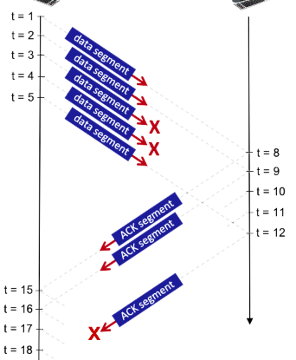**(5b)** As shown in the diagram, a TCP sender has sent 5 segments to the receiver at t = 1, 2, 3, 4, and 5, respectively. Suppose the initial value of the sequence number is 38 and every segment sent to the receiver contains 425 bytes. The delay between the sender and receiver is **7** units, and so the first segment arrives at the receiver at t = 8, and an ACK for this segment arrives at t = 15. Segments sent at t = 3 and t=4 are lost between the sender and the receiver, and one of the ACKs (sent at t=12) gets lost. Assume that there are no timeouts and any out of order segments received are thrown out. **[4+2+2 = 8]**

**(i)** What are the sequence numbers of the packets sent by the sender at t = 1, 2, 3, 4.

**(ii)** What are the Acknowledgment numbers sent by the receiver at t = 8, 12.

(iii) What will be the sequence numbers at

t= 15 and 16.

Solution:

1. Sequence numbers:

t=1: 38

t=2: 463

t=3: 888

t=4: 1313

1. Acknowledgment numbers:

t=8: 463

t=12: 888

1. Sequence numbers:  
   t=15: 2163   
   t=16: 2588

***CLO 3 (Question # 6,7 & 8):* Demonstrate** various classical routing and switching protocols via simulations.

**Question # 6: Answer the following questions: [5+ 7 = 12 Marks]**

**(6a):** Suppose thatonly three entries exist in the router’s forwarding table as shown below.

**Router Forwarding Table**

|  |  |
| --- | --- |
| **Address** | **Router Port** |
| 129.59.28.0/22 | Port 0 |
| 129.59.28.0/23 | Port 1 |
| 129.59.28.0/24 | Port 2 |

The router receives five packets with different destination IP addresses (as provided in I to V). For each packet with a given destination IP address, you are required to consult the router’s forwarding table, identify and write the router interface port to which the packets will be forwarded. [**1 x 5 = 5]**

1. Packet 1: Destination IP = 129.59.29.108. Which router port is this packet forwarded to?
2. Packet 2: Destination IP = 129.59.24.110. Which router port is this packet forwarded to?
3. Packet 3: Destination IP = 129.59.30.57. Which router port is this packet forwarded to?
4. Packet 4: Destination IP = 129.59.28.250. Which router port is this packet forwarded to?
5. Packet 5: Destination IP = 129.59.28.256. Which router port is this packet forwarded to?

**Solution:**

1. Packet 1: Port 1
2. Packet 2: Error. Doesn’t match any entry. (“Default” answer is not acceptable as router only has the above three entries and no other entry including any default entry)
3. Packet 3: Port 0
4. Packet 4: Port 2
5. Packet 5: Error. Invalid IP

**(6b)** A host wants to send a 5020-byte datagram (total datagram length with no options used) over an IPv4 network with a maximum transmission unit (MTU) of 2000 bytes. Thus, the datagram needs to be fragmented. Answer the following questions for the fragmentation process: **[1 + 3 + 3 = 7]**

1. How many total fragments will be made?

Answer : 3

1. What is the total size (in bytes) of each fragment respectively?

Answer : 1996, 1996, 1068

1. What is the offset value in each fragment respectively?

Answer : 0, 247, 494

**Question # 7: Answer the following questions: [8+1+1 = 10 Marks]**

**(7a)** Consider the following network. With the indicated link costs, use Dijkstra’s shortest-path algorithm to compute the shortest path from S to all network nodes. Provide all steps in a table and final diagram that shows the shortest path from S to all network nodes. [**5+3=8**]

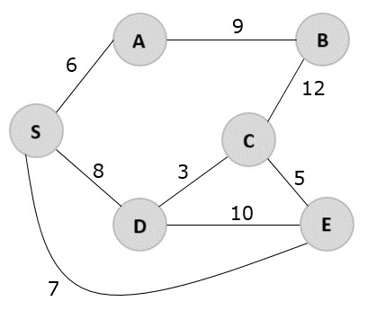

|  |  |  |  |  |  |  |
| --- | --- | --- | --- | --- | --- | --- |
| **Step** | **N’** | **A**  **D(A), p(A)** | **B**  **D(B), p(B)** | **C**  **D(C), p(C)** | **D**  **D(D), p(D)** | **E D(E), p(E)** |
| 0 | S | 6,S | ∞ | ∞ | 8,S | 7,S |
| 1 | SA | 6,S | 15,A | ∞ | 8,S | 7,S |
| 2 | SAE | 6,S | 15,A | 12,E | 8,S | 7,S |
| 3 | SAED | 6,S | 15,A | 11,D | 8,S | 7,S |
| 4 | SAEDC | 6,S | 15,A | 11,D | 8,S | 7,S |
| 5 | SAEDCB | 6,S | 15,A | 11,D | 8,S | 7,S |

**Solution**

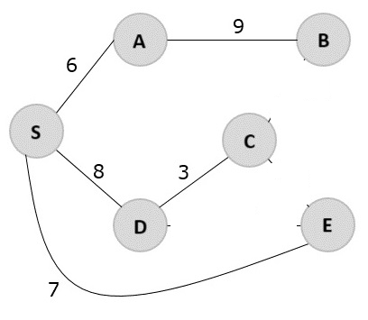

**(7b)** Which of the OSPF and BGP protocols is based on link state routing algorithm? **[1]**

**Answer:** OSPF

**(7c)** Which of the intra-AS and inter-AS routing is policy oriented? **[1]**

**Answer:** inter-AS routing

**Question # 8: Answer the following questions: [2 + 9 = 11 Marks]**

**(8a)** Refer to the diagram below. Host A has sent a packet to host B. What will be the source MAC and IP addresses on the packet when it arrives at host B?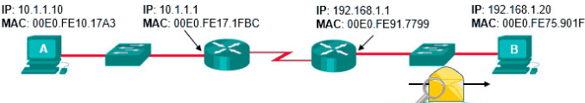

**Answer:**

**Source MAC: 00E0.FE91.7799  
Source IP: 10.1.1.10**

**(8b)** The figure below shows a network topology. The LAN on the left uses a NAT to connect to the Internet and includes a client host H1. The LAN on the right includes a webserver H2. Packets between the two endpoints are routed along the path shown by heavy dark lines. The various network interfaces have IP and MAC addresses as shown in the figure below.

H1 has established an HTTP session with web server H2 and data packets are flowing between the two machines.

You are required to fill in the header type and the source and destination address for the datalink and network layer headers for packets 1, 2, and 4 (these packets are traveling either from client H1 to server H2 or from server H2 to client H1, as marked on the figure with heavy black arrows and numbers). Note that you should order your headers, i.e., Ethernet should be listed before IP, because the Ethernet packet exists first on the wire.

**Write your answers for each packet as per the following template.**

|  |  |  |
| --- | --- | --- |
| **Header Type** | **Source Address** | **Destination Address** |
|  |  |  |
|  |  |  |

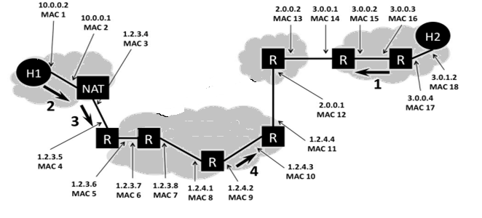

**Answer:**

**Headers for packet 1:**

|  |  |  |
| --- | --- | --- |
| **Header Type** | **Source Address** | **Destination Address** |
| **Ethernet** | **MAC 16** | **MAC 15** |
| **IP** | **3.0.1.2** | **1.2.3.4** |

**Header for packet 2:**

|  |  |  |
| --- | --- | --- |
| **Header Type** | **Source Address** | **Destination Address** |
| **Ethernet** | **MAC 1** | **MAC 2** |
| **IP** | **10.0.0.2** | **3.0.1.2** |

**Header for packet 4:**

|  |  |  |
| --- | --- | --- |
| **Header Type** | **Source Address** | **Destination Address** |
| **Ethernet** | **MAC 9** | **MAC 10** |
| **IP** | **1.2.3.4** | **3.0.1.2** |